shrines an derelict veracity- case of data ganj baksh ali hajwari lahore

Abstract
The shrines and their custodians in our society are valued as respect in our society. The department of Aukaf is in charge for managing the waqf properties attached to religious establishments. This paper discusses the institutional and legislative framework surrounding architectural conservation of shrines sited in Lahore along with other powers and urban milieu of these shrines that affect them. The data collected for this research are based on primary and secondary sources. The research findings are that there has been a recent trend of large-scale institutional approach towards reconstructing shrines buildings which generated with the Data Darbar Complex project. Other Grand mosques, along with public amenities and commercial areas are developed on waqf properties to increase revenues and facilitate za'ireen. Older but smaller mosques are mostly demolished in the wake of constructing modern and bigger mosques while shops are created on the peripheries to generate rental income. The future recommendation focuses on the need for incorporating aesthetical values in development projects aimed for places of spirituality. This demands inclusive project management techniques based on modern conservation trends in which the architects play a vital role. Training of the management staff and craftsman ship regarding the conservation techniques is highly needed for the future maintenance of these shrines.

KEY WORDS: Shrines, Data Darbar, Aukaf Department, Lahore, Conservation.
- INTRODUCTION:

Religion plays a vital part in the everyday life of a person around the globe. Every action of an individual is meant to be in conformity with the principles of that religion and this is what the individual strives for as well. Beliefs in this regard play a very important role, for it is the belief in the Supreme Deity, the Supreme Scriptures and the messengers that enable a person to follow this path of devotion. The usual method of professing devotion is through following the injunctions as laid down by the religion. Another form of displaying devotion, very commonly practiced in this part of the world is through visiting of shrines, tombs and mausoleums. This trend is found in all religions including Islam. The shrines here in Pakistan are of saints who are believed to be men of Allah and their role in spreading and preaching of Islam is noteworthy. The fact that shrines, big and small are spread all across the country shows the eminent presence of Sufism in the society and also displays the culture of pirs and sajjada nashins. In Pakistan, every Muslim, one way or the other, either is a believer of a mystical order or follows a pir with utmost dedication [1].

The person buried in the shrine is either a pir himself or a renowned saint. For every pir, generally, a shrine is built as a tribute to his/her mystical presence. These pirs play the role of an intermediary between the common man and God [2]. This common man is the devotee who requires a pir to be able to reach the congregation of Prophets and ultimately access God. The idea is that the God is the Supreme Deity who sent Prophets to guide people. These Prophets then passed away and since there is not to be another prophet, God chose the most pious of the His people to lead the common man to religion and to God. These pirs then pass on the message of God and religion to the people. The following of the pir depends on his or her ability in making that connection and also in his ability of bestowing blessings [3]. After the pir comes the place of a sajjada nashin who is the “holder of the shrine” and is selected by the pir as his successor. There are four types of shrines of the sufi orders Chisti Order, Suhrawardi Order, Qadiri Order and Naqshbandi Order. Chisti order shrines are largely found in Punjab.

Shrines are not only a hub of religious practice and avenues of devotion; they also play a part in the social, political and economic landscape of not only their particular geographical area but also of the country. Tombs and shrines in the Pakistani society are a nerve center of social activities. These places not only are there for divine intervention but also serve as avenues of interfaith unity and social harmony [4]. In a lot of instances, the local landlord is the pir himself or is a very close associate of the local landlord [5]. The landlord ensures that the local villagers contribute materially to the well-being of the shrine as well as the pir. Politically, the state used shrines as a means of interacting with the general population at the emotional as well as physical level [6]. For this purpose, the urs, the annual death anniversary celebration, is considered as the best time. Keeping a control on shrines is a means of harboring political ties between state and society. Through this the state creates an allegiance towards itself.

A comprehensive database of shrines spread all over Punjab which contains a total of 598 shrines tells that Lahore has the largest number of shrines in Punjab, followed by Multan and Rawalpindi [7]. The numbers are 73, 20 and 17 respectively. The presence of shrines is not a rural phenomenon, in fact, urban centers tend to have a higher concentration of shrines but Sufis preferred to settle outside the walled cities and get buried in their Hujrahs upon death. Some notable shrines present in Lahore include Darbar Hazrat Ali Huajweri aka Data Gunj Bakh, Darbar Hazrat Mian Meer, Darbar Bibi Pak Daman, Darbar Pir Makki Sharif, Hazrat Meeran Mauj Darya, Darbar Shah Hussain and Darbar Shah Jamal.
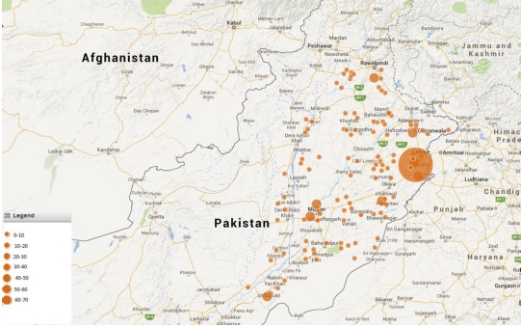
Figure 1: Shrines in Pakistan source Malik & Mirza, 2015
NO | SHRINE NAME | ILLUSTRATION | NO | SHRINE NAME | ILLUSTRATION
1. | Bibi Pak Daman, near Shimla Pahari, Lahore. | 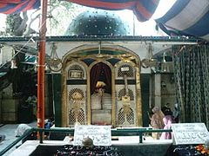 | 2. | Hazrat Mian Mir , Darbar Dharampura, Lahore. | 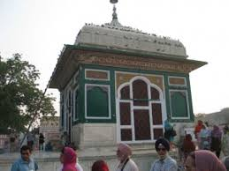
3. | Hazrat Pir Makki shrine,  Near Data Gnj Baksh, Lahore. | 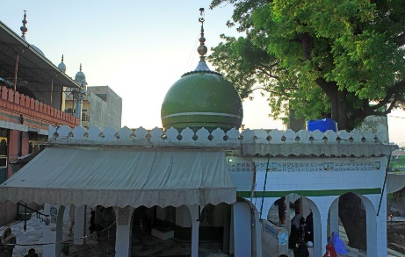 | 4. | Shrine of Mauj Darya, Anarkali Bazar Lahore | 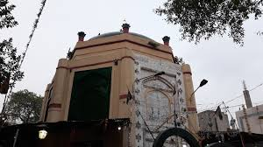
5. | Shrine of Madhu Laal Hussain, Bagbanpura Shalimar Gardens Lahore. | 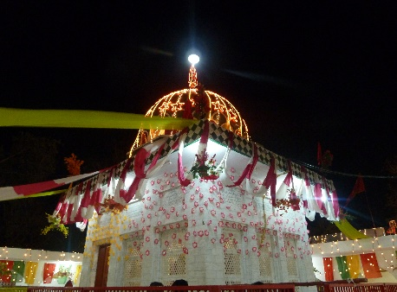 | 6. | Shrine of Shah Jamal, near Shadman Lahore. | 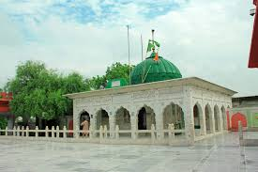
Table1: Example of some noble Shrines in Lahore.
- METHODOLOGY:
The main objective of this research is to study the impact of these shrines in the physical structure and the cultural profile of the city as an architectural entity. The research focuses on these shines in our society along with the legislative framework regarding the conservation of these historical shrines with the contribution of the related authorities. The facts collected for this study on the shrines were taken from the primary and ancillary sources of historic literature on shrines which was further proved by a detailed study of the legislative framework and policies in the acts, followed by several site visits of Data Gunj Baksh Lahore. The collected data was studied with reference to the architectural conservation policies for these shrines and their sustainability practices.
- results and discussion

A thorough research reveals that there is a shortage of comprehensive conservation policies in Pakistan. The legislators have devised two statutes which provide protection to buildings of historical significance. These are THE ANTIQUITIES ACT 1975 and THE PUNJAB SPECIAL PREMISES (PRESERVATION), ORDINANCE, 1985respectively.

The Antiquity Act 1975 of the Parliament has been designed for the preservation of movable and immovable antiquities. It has provisions for enlisting historical buildings like shrines and mosques as 'protected', guardianship of such properties, representation against declarations by the Archaeology Department, protection of places of worship and prohibition against damage and destruction of protected antiquities. Once declared 'protected', properties cannot be damaged and demolished in any case. Repair works can also take place on the orders of Director General Archaeology, which has been devolved to provincial government under the 18th Amendment. Section 22 of the Act clearly states that:

"No development plan or scheme or new construction on, or within a distance of two hundred feet of, a protected immovable antiquity shall be undertaken or executed except with the approval of the Director"

While with regards to protecting the sanctity of shrines and other places of worship, Section 17 states that:

"A place of worship or shrine, being an antiquity maintained by the Federal Government, shall not be used for any purpose inconsistent with its character"

Whereas, in order to specifically preserve certain premises of historical and architectural value in Punjab and to control and regulate their alterations, demolition, re-erection and ancillary matter thereto, the Punjab Special Premises (Preservation) Ordinance, 1985 was promulgated. This ordinance uses a term 'committee' instead of the Director Archaeology. Section 11 of the ordinance also prohibits any construction within 200 feet of the special premises except with the prior approval of the Government or its committee. While Section 5 states:

"No alteration in or renovation, demolition or re-erection of such portion of a Special Premises as is visible from outside, or any part of such portion, shall be effected without the prior permission in writing of the Government or a Committee."
However, this ordinance doesn’t mention anything about the procedure of formulation of such committees. Legal complexities can develop if government prefers to choose a majority of members from within the government instead of independent architectural experts, historians and other stakeholders just as in the case of Metro Orange Line Project. Due to this project, construction is bound to take place within 200 feet of Darbar Mauj Darya and certain other entities as observed is mandatory when as the situatin is opposite. As a result some of the concerned citizens, groups and NGO’S petitioned against the issuance of NOC by Director Archaeology and formulation of decision committee.

The majority of the mosques and shrines in our society are managed by voluntary local organizations. With the passage of time, deterioration in the running affairs of these important mosques and holy shrines created the need for the restoration of their sanctity. Auqaf Organization was formed as a legal entity in the year 1959, through the "West Pakistan Waqf Properties Rules" of 1960 aimed at "regulating" endowments [8] and controlling the political powers of the mullahs and pirs, especially in rural areas [9]. Auqaf ordinance issued through the 1960s and 70s were all part of an attempt to bring the rhetoric about shrines and mystics in line with the Islamic beliefs as the charge that pilgrims visiting shrines engage in un-Islamic behavior is a common one [10]. Currently this department works under the Punjab Waqf Properties Ordinance, 1979.

The Auqaf Organization is a self-funded body where the basic funding is received from shrine donations, leases of agricultural lands and rents from commercial and residential properties. The funds generated are utilized for education, medical facilities, social welfare, academic scholarships and the upkeep of important religious monuments and holy places.According to the Punjab Waqf Properties Ordinance, 1979, the functions performed by this department are the control of mosques, shrines and other religious institutions under the Chief Administrator of Auqaf, Punjab. The management of central Auqaf fund, regulation of religious trusts, administration of Muslim Graveyards and preparation of religious education schemes. Followed by the printing and Publication of the Holy Quran including administration of the publication of the Holy Quran (Elimination of Printing & Recording Errors) Act, 1973.

There are many influential shrines in rural areas that have been allowed by the provincial government to maintain their independence and have been functioning with the blessings of powerful religious families [11]. Auqaf department has performed reconstruction and expansion works on several important shrines under its reclaim. These works include the provisioning and restoration of public amenities, construction of attached mosques, and development of commercial properties on the open waqf lands and conservation of dilapidated structures. There are two types of shrines categorized by two legislative pieces i.e. Waqf properties Ordinance 1960 and Special Premises Preservation Act 1985. The first type of shrines are the ones in which Auqaf department has full jurisdiction to perform repair and maintenance work, while for the second type of shrines, approval of the Archaeology Department is mandatory for performing any sort of reconstruction work under the Special Premises Act 1985. The second category includes shrines which have been enlisted as 'protected' due to their historical significance.

The expansion project of the Shrine of Hazrat Data Ali Hajveri near Bhaati gate in Lahore has been consistently hailed and criticized as the flagship project for such reconstruction works under the supervision of public entities. The policy of turning shrines into multifunctional social and religious hubs administered by Auqaf, began in Ayub's era and continued under Zia-ul-Haq announced the expansion of hospital associated with the shrine and construction of Lahore's second largest mosque in Data Darbar premises [12]. This project began in the year 1981 and completed in the year 1999. It took nearly 20 years due to lack of funds available to both federal and provincial governments. Originally the shrine covered an area of 3125 sq. feet but nearly 33333 sq. feet of built area was added to the shrine. Later on, the whole building structure was called as the Data Darbar Complex. Hazrat Data Ali Hajveri passed away in 1072 A.D.
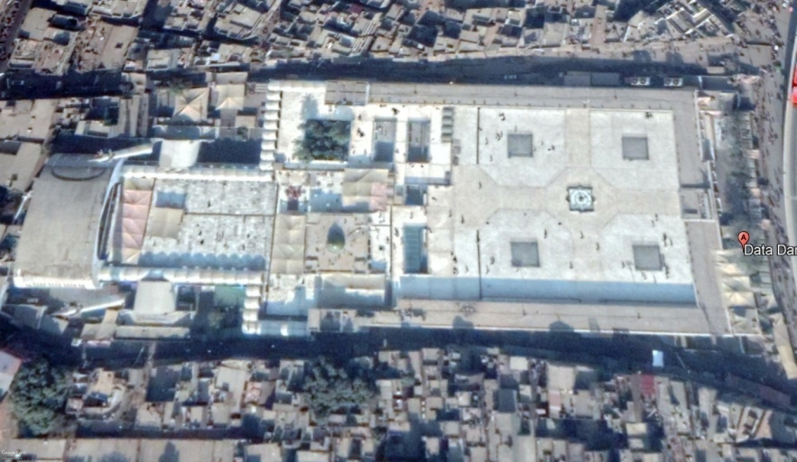
Figure 2Ariel view of Data Ganj BakshSource author, retrieved from google map on 30th march, 2017
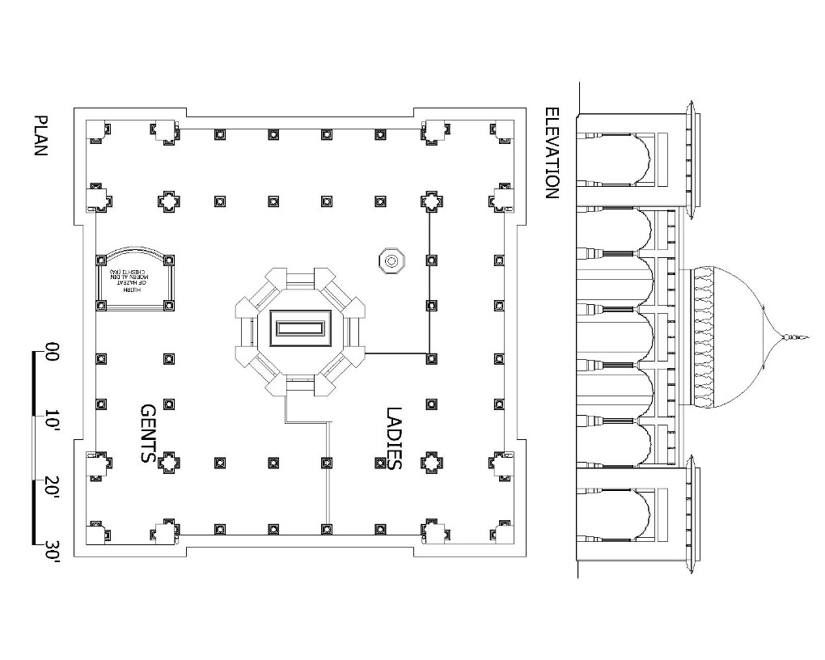
Figure 3 Plans and Elevation of Data Ganj Baksh
Source: Shehzad, G. (2001).
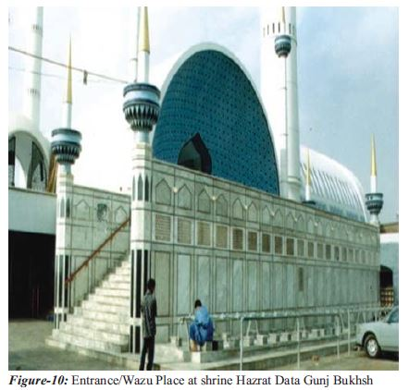
Figure 4 (shehzad, 2012)
A large mosque was built near the original shrine building with tall minarets. Several other amenities like the underground car parking, seminar hall, sama'a hall, air-conditioning system, water-storage system, ablution area, lavatories, lost & found section, police check-post, office of jahez (dowry) committee and an extensive shoe-rack section were provided in this project. This project greatly facilitated the increasing number of zaireen (vsitors) visiting the shrine and led to increased collection of donations for the Auqaf Department.

There has been a tremendous change in the built environment of Data Darbar shrine after the completion of this project. Old incremental development strategies for shrines have been replaced by this modern mega-project style development strategy. The construction of mega-mosques alongside shrines as the construction of large minarets creates an overpowering religious perception, often undermining the spiritual ambiance of the shrine. The socio-religious environment of the shrine is becoming more Islamized rather Islamicate [13]. Often times, such modern and large-sized mosques are built after demolishing historical but small-sized mosques. Even thoughseveral historical shrines like the Data Darbar, Darbar Baba Bulleh Shah and Darbar Baba Farid are enlisted and protected under the Special Premises Act 1985

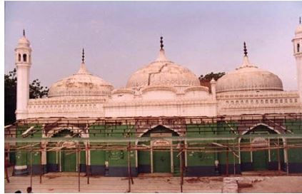
Figure 5 Tughlaq Era mosque at Darbar Baba Farid demolished (Shehzad, 2002)
Civil societies and concerned architects have shown resentment against theseillegitimate acts of different provincial government departments which continue to damage historical and protected properties under the disguise of reconstruction and modernization. Construction of large-scale mosques near shrines is another such trend which hasn’t been appreciated by conservationists advocating originality. Usage of building materials and architectural designs which are not matched to the subcontinent's historical landscape. Also observed that most of the shrines reconstructed by Auqaf Department Punjab had no prior minaret structure but with the reconstruction work, large minarets were erected which has changed the architectural character of these shrines towards mosques. This trend continued with the reconstruction of Darbar Baba Farid in Sahiwal and Darbar Baba Bulleh Shah.
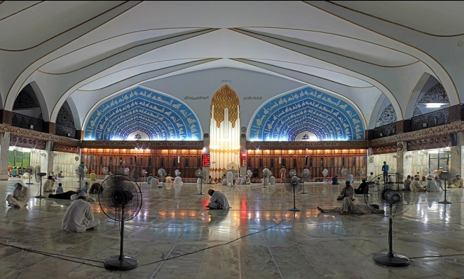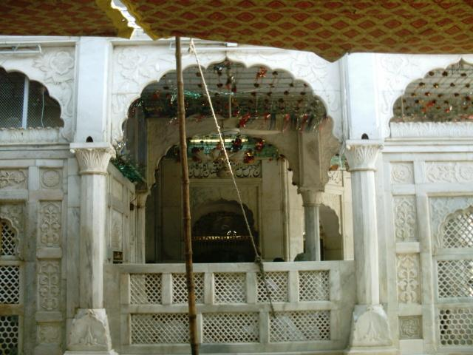
Figure 6: View of the new mosque's interiorFigure 7:cenotaph with marble screens
In 1278 Noor Muhammad Sadhu construct strong dome (Gumbad) So that in 1309 late Molvi Firoz din of carved white marble Sang e Mar Mar instead of Chobi Jalies and afterward Abdul Majeed crafted calligraphic poetry on Ramza Mubarak. In 1968 dome got cracks in it and then Major Ibrahim renovated the dome. Sūrah Yā-Sīn verses and name of Allah written by late Haji Din Muhammad. Jilal ul din Akber rebuilt the Hujra e aitkaf of Hazrat Khwaja Moeen ul din Chishti, Afterward white stone latticed screen were being fixed by Department Auqaf Punjab. Similarly, one door was construct at north side only for women. There has been a lot of decay that Data Darbar has faced over the period of time yet there is lack of management seen in retaining these structures.
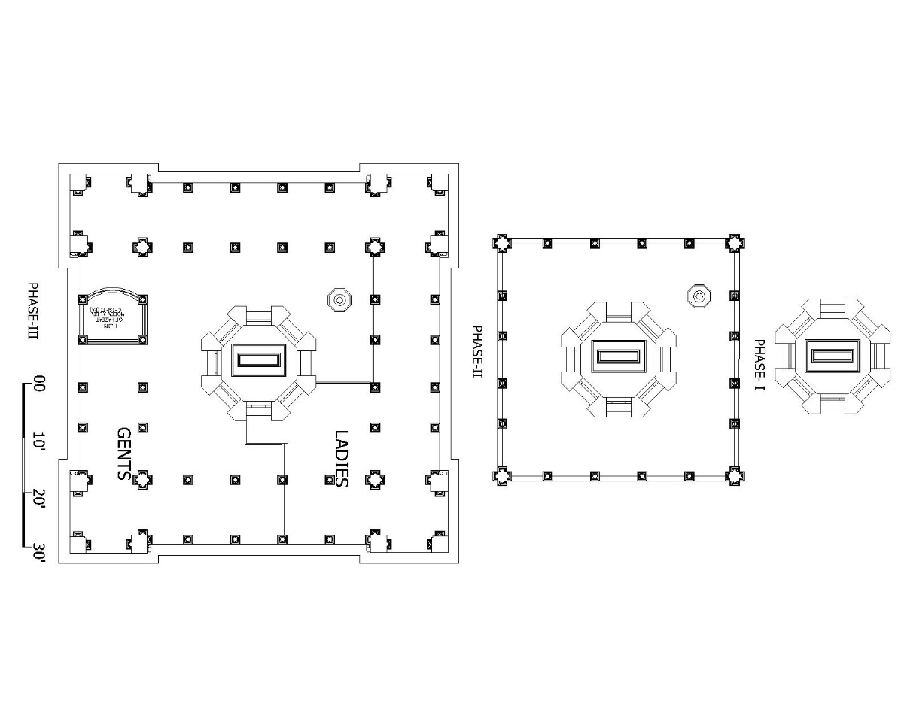
: Figure8: The Three Phases of expansion of Data Ganj Baksh

- Conclusions:
With growing numbers of za'ireen there would be a demand for retail items, especially considering the fact that most of them come from far-flung areas of the country. In placeswhich are symbols of spirituality and sanctity,these shops have severely reduced the visibility of main entrances. Shrines located in dense urban areas have to bear this phenomenon at an alarming magnitude. Construction of Data Darbar Complex introduced the new institutional approach towards shrine reconstruction,before this project only small incremental changes were performed on shrine buildings mostly sponsored by mutawalis and the Auqaf [14]. The land acquired through the Land Acquisition Act 1894, which does mandate the disbursal of compensation amounts on market rates but miss on several other necessary items (e.g. compensation for temporary business owners who don’t possess any legitimate sale deed). Shrines in large urban centers like Lahore generate the bulk of revenues for Auqaf Department. In recent years, there has been a healthy growth in these revenues (Data Darbar tops the list with 8 percent increase between years 2015-16). This uneven pattern is one of the biggest hurdles in the formulation of an inclusive conservation approach for all the shrines under Auqaf's control.

Targeted aids and grants from international donors like the USAID and DFID can help in reducing such tendencies of Auqaf and provincial government departments. USAID through the Ambassador's grant of $50,000 helped Auqaf department in restoring the shrine of Hazrat Jalaludin Surkhposh in Uchh Sharif, South Punjab. Auqaf's Director Projects, Muhammad Shabbir Malik led the team of artisans and workers which performed the restoration work of the dilapidated shrine structure [16]. Similarly, construction of new and larger mosques in the premises of Darbar Baba Bulleh Shah, Darbar Baba Farid and Darbar Shah Hussain have been performed through grants issued by the provincial government. Baba Bulleh Shah Shrine now comprises of the main tomb, attached mosque and its 102 feet high minarets, a library, arcade, two-way entrance to the shrine, landscaping and an administrative block.

- Recommendations
There is strong need for the strengthening of Architecture Directorate in various provincial government departments, especially within Aukaf Department and Communication & Works C & W Departments. Architects and conservationists having expertise in conservation process based on originality and aesthetics should play a leading role in shrine reconstruction projects instead of engineers and economists who focus solely on cost-benefit-analysis[20].

Field investigations, laboratory work and archives research should be made an integral part of conservation plans and results obtained through research should be implemented during the project. Training of technical staff in modern project management techniques is the need of the hour.Shortage of skilled craftsmen due to the scarcity of conservation activity should be replenished through practical training programs and Technical & Vocational Training Authority (TEVTA) should be engaged in the process.

Architectural conservation should be a part of environmental planning and management. The conservation plan must address the problems at macro level even beyond the site as noise, vibration of heavy traffic and all kind of environment pollution is affecting historic monuments [21].Modern technology should be used to improve transparency in Auqaf Department's donation collection and disbursal methods. Point of Sales (POS) machines, other devices with central real-time monitoring system can be used for the purpose of streamlining accounting and accountability.

vi. References
[1] Malik, S.J. (1990). Waqf in Pakistan: Change in Traditional Institutions. Die Welt des Islams, 30, 63-97.

[2] Naliyawala, H. (2016). Mother Makli: A Living Heritage. Tanqeed. Retrieved from http://www.tanqeed.org/2016/02/mother-makli-a-living-heritage/

[3] Malik, S.J. (1990). Waqf in Pakistan: Change in Traditional Institutions. Die Welt des Islams, 30, 63-97.

[4] Chawla, M.I, Shoaib, R & Iftikhar, A. (2016). Female Sufism in Pakistan: A Case Study of Bibi Pak Daman. Pakistan Vision, 17(1), 224-247.

[5] Malik, S.J. (1990). Waqf in Pakistan: Change in Traditional Institutions. Die Welt des Islams, 30, 63-97.

[6] Philippon, A. (2012). The ‘urs of the patron saint of Lahore: national popular festival and sacred union between the Pakistani State and society? Social Compass, 59(3), 289-297.

[7] Malik, A & Munir, R.A. (2015). Religion, Land and Politics: Shrines and Literacy in Punjab, Pakistan. Islamabad: USAID.

[8] Malik, S.J. (1990). Waqf in Pakistan: Change in Traditional Institutions. Die Welt des Islams, 30, 63-97.

[9] Ansari, S.H. (2011). Forced Modernization and Public Policy: A Case Study of Ayub Khan Era (1958-69). Journal of Political Studies, 18(1), 45-60.

[10] Zaidi, N. (2016). "A Blessing on Our People”: Bibi Pak Daman, Sacred Geography, and the Construction of the Nationalized Sacred. The Muslim World, 104, 306-335.

[11] Malik, A & Munir, R.A. (2015). Religion, Land and Politics: Shrines and Literacy in Punjab, Pakistan. Islamabad: USAID.

[12] Ewing, K. (1983). The Politics of Sufism: Redefining the Saints of Pakistan. The Journal of Asian Studies, 42(2), 251-279.

[14] Shehzad, G. (2001).To investigate the forces acting at religious magnet- The shrine in urban settlements and their impact on immediate surroundings, Ph.D. thesis dissertation, submitted to department of Architecture, UET, Lahore.

[15] Latif, R. (2009). Refurbishment of Bulleh Shah Shrine completed. The Nation. July 14, 2009.

[16] Shehzad, G. (2009). Reconstructing a Public Heritage Building Case Study: Western Wing of Lahore High Court Building, Lahore. Journal of Research in Architecture and Planning, 8, 31-43.

[17] Rehman, A. (2011). Conservation of Historic Monuments in Lahore: Lessons from Successes and Failures. Pak. Journal of Engineering & Applied Science, 8, 61-69.
Retrieved from http://nation.com.pk/lahore/14-Jul-2009/Refurbishment-of-Bulleh-Shah-shrine-completed.
[18]farhat rasul, u. f. (2016). Religion Tourism and Entrepreneurial Development. lahore: siuth asian studies. Retrieved from http://pu.edu.pk/images/journal/csas/PDF/18%20Farhat%20Rasul_v31_no1_jan-jun2016.pdf

