ANNEXURE II
Template for manuscript preparation

TITLE PAGE OF THE MANUSCRIPT FOR JTPAD WITH TITLE CENTRED IN UPPER CASE AND BOLD WITH FONT SIZE OF 14 PT

Author one¹, Author two^{2*}, Author three³ (Times New Romans, 12 pt)
1. Full institutional affiliation including email address (Times New Roman, Italicized -11 pt)
2. Full institutional affiliation including email address (Times New Roman, Italicized -11 pt)
3. Full institutional affiliation including email address (Times New Roman, Italicized -11 pt)

* Corresponding Author: Name, contact and Email address: (Times New Romans-12 pt)

ABSTRACT

Abstract should be presented on a separate sheet with heading of ABSTRACT in bold with font size of 14 Pt whereas the text italicised with font size of 12 Pt. This should be followed by five to seven KEY WORDS and word count of abstract which should not be more than 300 words

KEY WORDS: Key word one, key word two, key word three, key word four, key word five

1. INSTRUCTIONS CONCERNING MAIN TEXT
This section provides comprehensive guidelines for authors regarding the preparation and formatting of the main text of the manuscript. It outlines the essential components, structural requirements, and stylistic conventions that should be followed to ensure clarity, consistency, and adherence to publication standards.

2. GENERAL INSTRUCTIONS FOR HEADINGS
All headings should be numbered in sequence, aligned with left margin in UPPER CASE and bold but with font size of 12 Pt using single line spacing.

2.1. General instructions for sub-headings
All sub-headings should also be aligned with left margin in sentence case and bold with font size of 12 Pt using single line spacing.

2.2. Page numbering
The entire manuscript should be numbered and the page numbers should appear in the top right corner of the page.

2.3. Line spacing
Single line spacing should be used when writing paragraphs. However, authors are advised to insert a double space between consecutive paragraphs and at the start of each new heading and subheading to enhance readability and maintain formatting consistency.

3. STRUCTURE OF MAIN TEXT
The main text should comprised of introduction, materials and methods, results and discussion, conclusions and recommendations sections. Overall the main text of the manuscript should be fully justified on standard A4 page format with normal margins. Moreover, the word count for the paper should be provided at the end of the references list in the manuscript.

4. FIGURES TABLES AND EQUATIONS
Figures including pictures and tables can be placed within the text with captions above the figure/table and source below the figure/table leaving double line spacing above and below from the text. The caption and the source should be left aligned. Each figure (see figure 1) and table (see table 1) must be clearly cited in the main text at the point where it is most relevant to the discussion.

Figure 1: Proposed title page of the journal Figure 2: Official logo of UET, Lahore
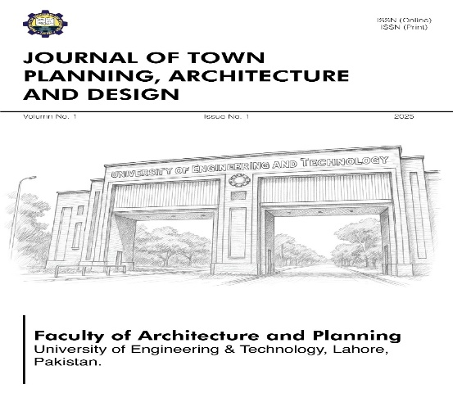
Source: Salman, 2025 Source: UET Lahore, 2025

Table 1: Sample table as a guide for the authors
Sr. No. | Category | Frequency | %age
1
2
3
Source: EB, 2025

Kindly note that figures should be of sufficient resolution to enable refereeing. Furthermore, equations (if any) can also be placed within the text without any numbering but these should be editable.

5. REFERENCES
Harvard style of referencing (for instance see Skills for Learning, 2009) should be used for citing in the text as well as for the list of references.
Skills for Learning, 2009. Quote, Unquote: A guide to Harvard Referencing. Leeds Metropolitan University.
Weerawardane, D. and Byrne, P., 2021. An introduction to critical thinking, academic writing and Harvard referencing. In: Academic Development and Employability. Harlow: Pearson Education Limited. Ch. 1. pp. 3-54.

WORD COUNT: 611

ACKNOWLEDGEMENTS
Authors may include a section of Acknowledgements at the end of the list of references, using the heading ACKNOWLEDGEMENTS and maintaining single line spacing.

Note: Appendices (if applicable) can be provided using the guidelines presented above.

